Initial dataset has 94 fastq files genotyped at 352 loci and a sex marker. 8 duplicate fastq files with repeat sample_simple IDs are positive controls.

Look at concordance between 8 positive controls and their corresponding samples:

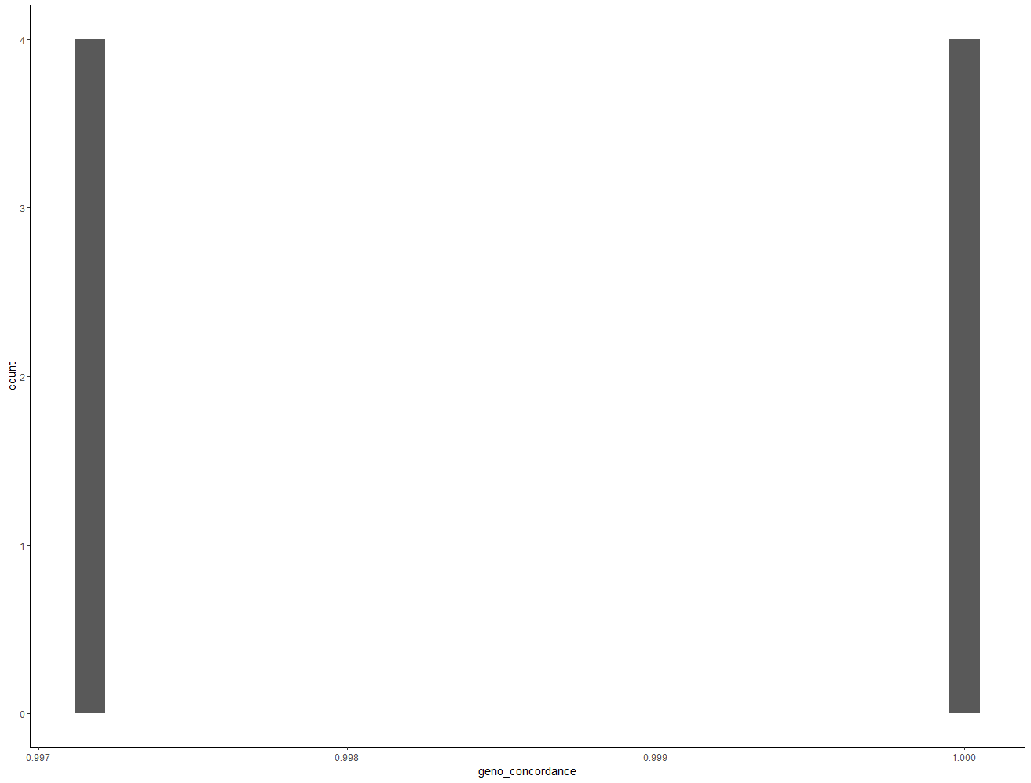

##concordance between quality controls and corresponding samples is high (0.997 - 1.0)##

Kept duplicate samples with the higher genotyping success. Removed duplicates with lesser genotyping success.

##dataset now has 86 unique samples genotyped at 352 loci and one sex marker##

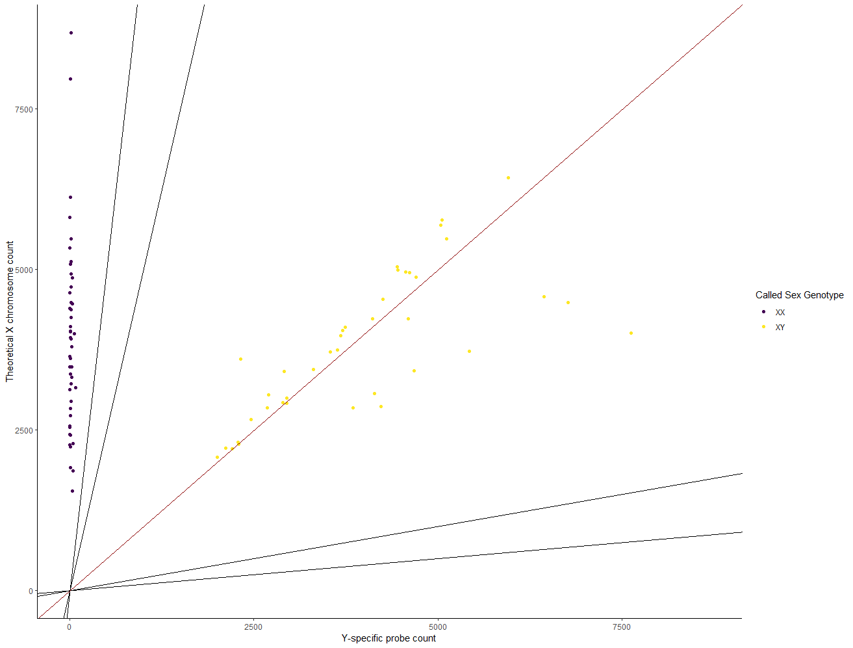

###Sex marker looks good. Leave as is without "correction" script##

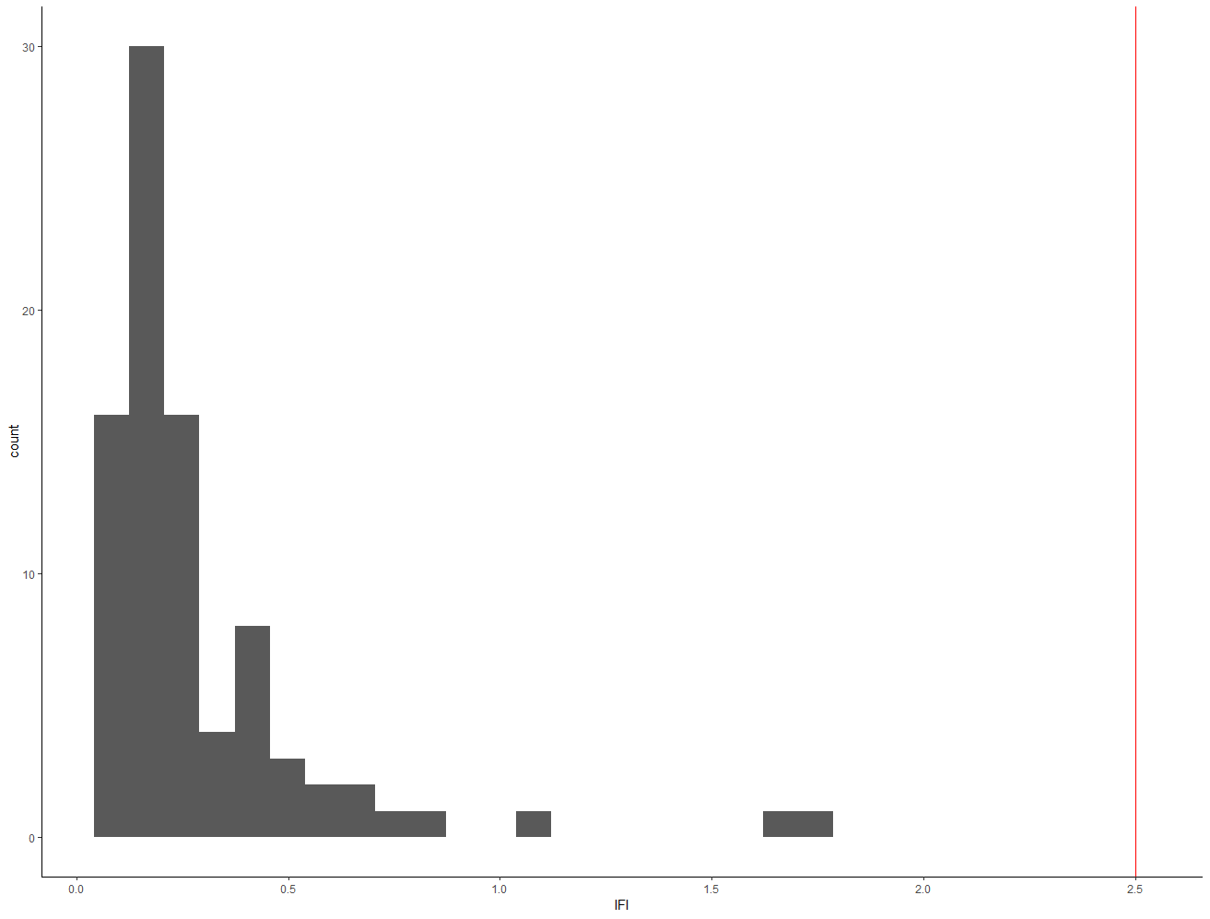

Filter individuals/markers based on call rates/IFI scores:

Initial IFI scores. All samples have good IFI scores.

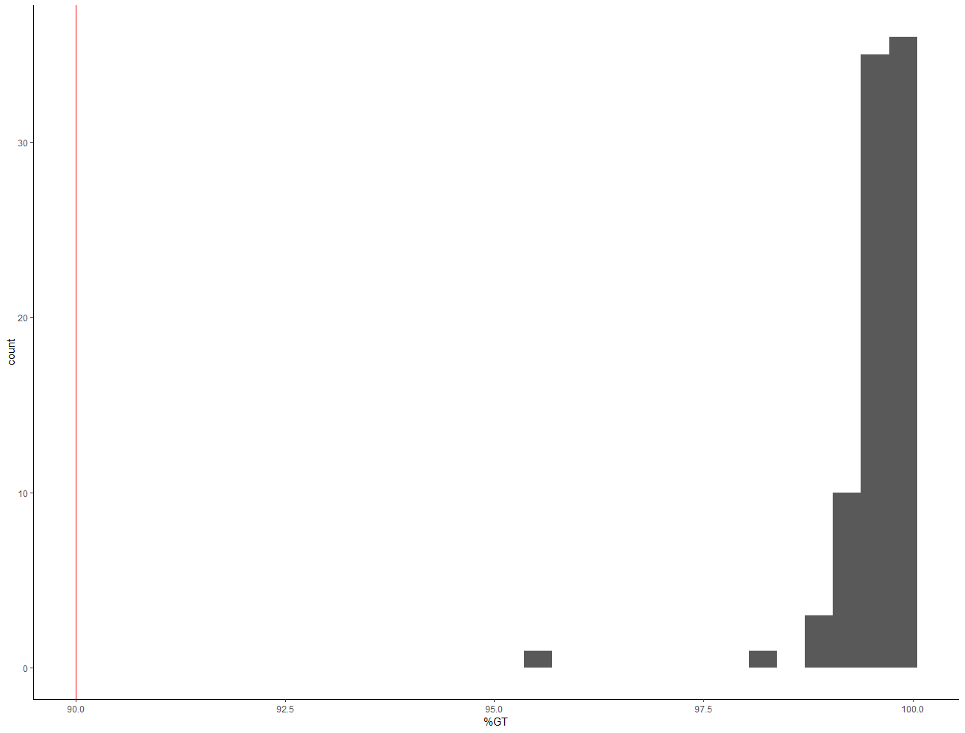

All samples are well genotyped. All samples have greater than 90% call rates

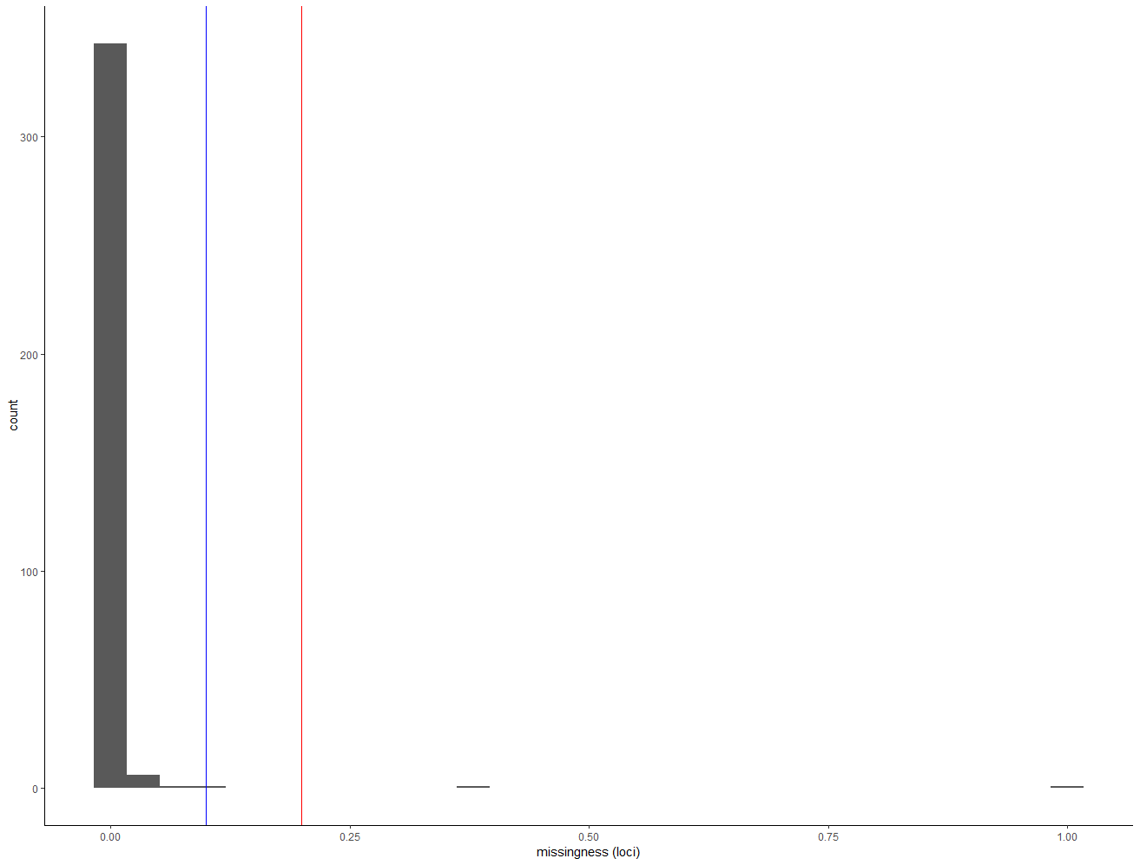

Most loci are well genotyped. Two missing in more than 20% of individuals. One (Ots_wenYhap_33126) not genotyped in any individual.

Removed locus not genotyped in any individual. Recalculate individual call rates.

0 individuals have call rates below 90%

1 marker missing in more than 20% of individuals (Ots_RAS1)

Removed this marker. Recalculate IFI scores.

0 individuals have IFI scores greater than 2.5.

##At this point the dataset has 86 Individuals and 350 loci and a sex marker##

##Individual call rates range 95.7 - 100%; Marker call rates range 89 - 100%

##IFI ranges 0.09 - 1.71##

Evaluate for potential PSVs:

##1 marker is potential paralog

Ots_MetA

Removed it.

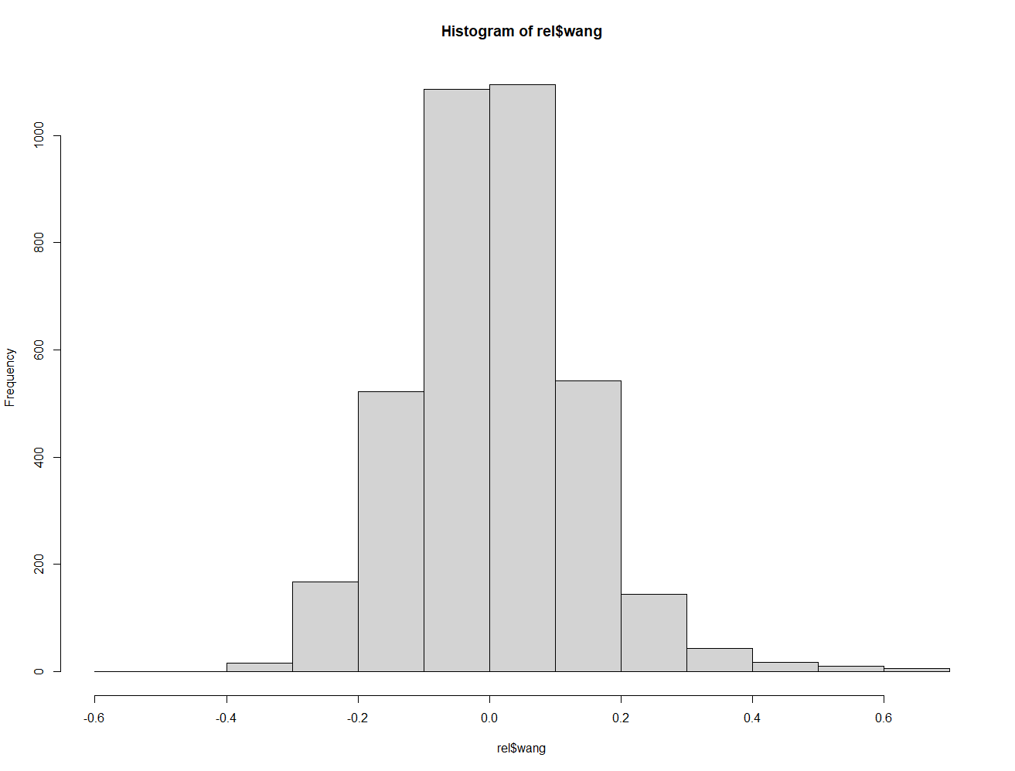

No duplicate samples detected with relatedness in coancestry

##74 monomorphic markers##

##"Ots11_11925999" "Ots11_32418659" "Ots17_1066109_C6" "Ots17_1345774_C6" "Ots17_1486479_C6" "Ots17_1488679_C6" "Ots17_885364" "Ots18_32088284"

#"Ots19_46172133" "Ots19_46172427" "Ots28_11202190" "Ots28_11205423" "Ots28_11206740" "Ots2_42405643" "Ots33_19359879" "Ots4_40942276"

#"Ots4_41638710" "Ots4_64978818" "Ots5_44795073" "Ots5_70908626" "Ots7_51409415" "Ots7_53631522" "Ots7_54212944" "Ots9_28975221"

#"Ots_123048-521" "Ots_123921-111" "Ots_127760-569" "Ots_129144-472" "Ots_129870-55" "Ots_97660-56" "Ots_ARNT" "Ots_CCR7"

##"Ots_CHI06027687_143477" "Ots_CHI06048618_5222" "Ots_GH2" "Ots_GPH-318" "Ots_GST-207" "Ots_GST-375" "Ots_GTH2B-550" "Ots_GnRH-271"

#"Ots_IGF-I_1-76" "Ots_IL8R_C8" "Ots_Ikaros-250" "Ots_IsoT" "Ots_LWSop-638" "Ots_Myc-366" "Ots_NFYB-147" "Ots_SL"

#"Ots_U2362-330" "Ots_U2567-104" "Ots_crRAD18937-60" "Ots_crRAD23631-48" "Ots_crRAD255-59" "Ots_crRAD26081-28" "Ots_crRAD46081-56" "Ots_crRAD46751-42"

#"Ots_crRAD55400-59" "Ots_hnRNPL-533" "Ots_hsc71-3'-488" "Ots_nkef-192" "Ots_nramp-321" "Ots_pigh-105" "Ots_stk6-516" "Ots_tpx2-125"

#"Ots_txnip-321" "Ots_u07-20_332" "Ots_u07-25_325" "Ots_u07-64_221" "Ots_u1008-108" "Ots_u211-85" "Ots_wenYhap_106664_9" "Ots_wenYhap_25067_92"

#"Ots_wenYhap_71572" "Ots_zn593-346"

At this point the dataset has 86 individuals and 275 markers and a sex marker.